As my ID is 24101610 ; i run the program 4 times
At first , 2410 ;
Then 1610 ;
Then the reverse of 2410 is 0142 and i take 142
Then the reverse of 1610 is 0161 and i take 161

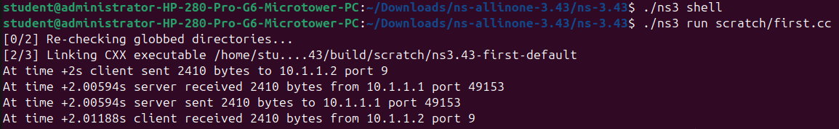
For 2410

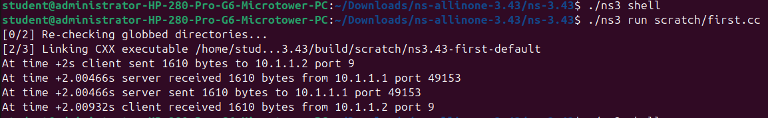
For 1610

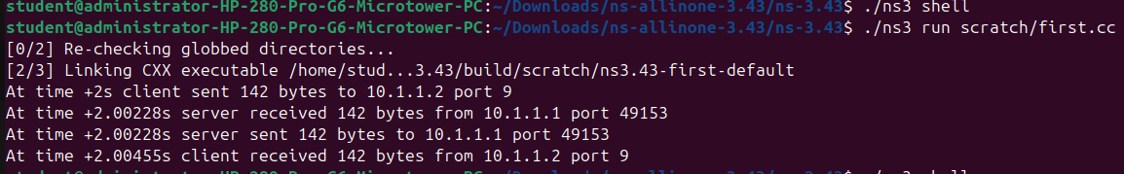
For 142

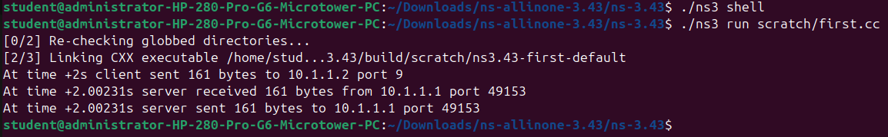
For 161

Throughput= (Bytes*8)/time

For 142 bytes, throughput= (142*8)/0.00455= 249,670
For 161 bytes, throughput= (161*8)/0.002315= 557,575
For 1610 bytes, throughput= (1610*8)/0.00932= 1381,974
For 2410 bytes, throughput= (2410*8)/0.01188= 1622,895

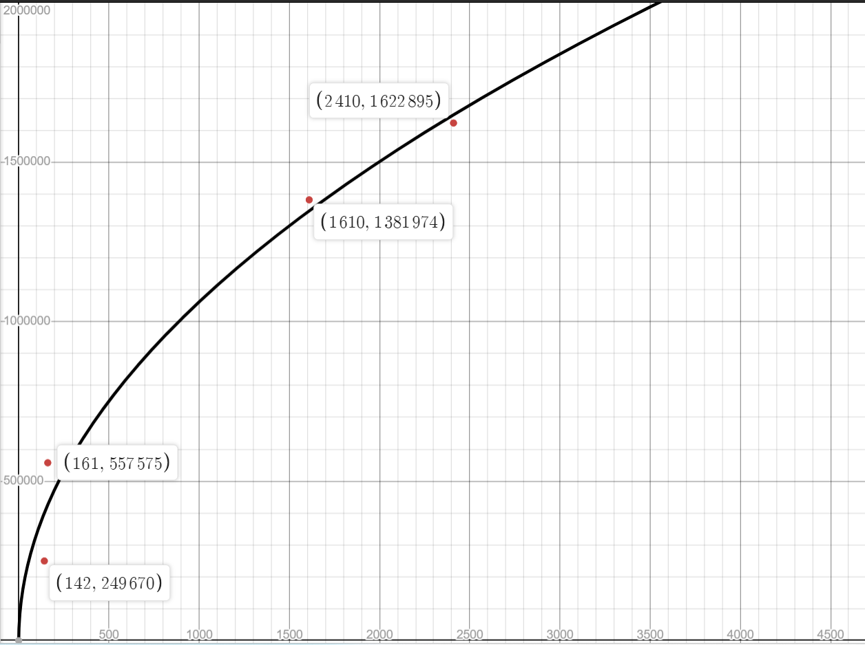
In this graph, x-axis is data size(bytes) and y-axis is throughput. It is an increasing graph. The centre point (100,100000)

